**Supplemental Materials**

**Supplemental Fig 1. Selective ablation of Lgr5+ Deiters’ cells in the P28 mature cochlea.** (A) Schematic of experimental timeline: DT was injected at P21, EdU was injected at P23-P25 and cochleae were harvested at P28. (B) Lgr5-EGFP expressions in the third row Deiters’ cells (DC3) in undamaged P28 *Lgr5DTR-EGFP/+* cochlea. The majority of DC3 in both the middle and basal turns of DT-treated *Lgr5DTR-EGFP/+* P28 cochlea was lost. (C) Some DC3 remained in the basal turn of DT treated *Lgr5DTR-EGFP/+* cochlea. No Ki67+ Sox2+ supporting cells were found in either wildtype or *Lgr5DTR-EGFP/+* cochlea. Asterisks in orthogonal view (B) and (C) highlight loss of both third row of outer hair cells and DC3 in *Lgr5DTR-EGFP/+* P28 cochleae. IHC, inner hair cells; OHC1, 2, 3, first, second, and third rows of outer hair cells; IPhC, inner phalangeal cells; IPC, inner pillar cells; OPC, outer pillar cells; DC1 and 2, first and second rows of Deiters’ cells. Data represent the mean ± SD. \**p*<0.05，\*\**p*<0.01 (two-way ANOVA with Sidak’s multiple comparisons test). n = 5-6. Scale bars: 20 µm.

**Supplemental Fig 2.**

**Selective ablation of Lgr5+ Deiters’ cells in the mature P56 mature cochlea.** (A) Schematic of the experimental timeline. (B) ABR and DPOAE thresholds were significantly higher in P56 *Lgr5DTR-EGFP/+* mice as compared to wildtype. (C) In DT treated P56 *Lgr5DTR-EGFP/+* cochlea, most of the third row of OHCs (OHC3) in the basal turn was lost, similar to the apical and middle turns (dot lines). This coincided with the loss of the third row of DCs (DC3) in all three turns. No Ki67+ Sox2+ supporting cells were found in the P56 wildtype or *Lgr5DTR-EGFP/+* cochlea. Asterisks in orthogonal view highlight loss of both OHC3 and DC3 in *Lgr5DTR-EGFP/+* cochleae. IHC, inner hair cells; OHC1 and 2, first and second rows of outer hair cells; IPhC, inner phalangeal cells; IPC, inner pillar cells; OPC, outer pillar cells; DC1 and 2, first and second rows of Deiters’ cells. Data represent the mean ± SD. \**p*<0.05，\*\*\**p*<0.001 (two-way ANOVA with Sidak’s multiple comparisons test). n = 4-5. Scale bars: 20 µm.

**Supplemental Figure 1**

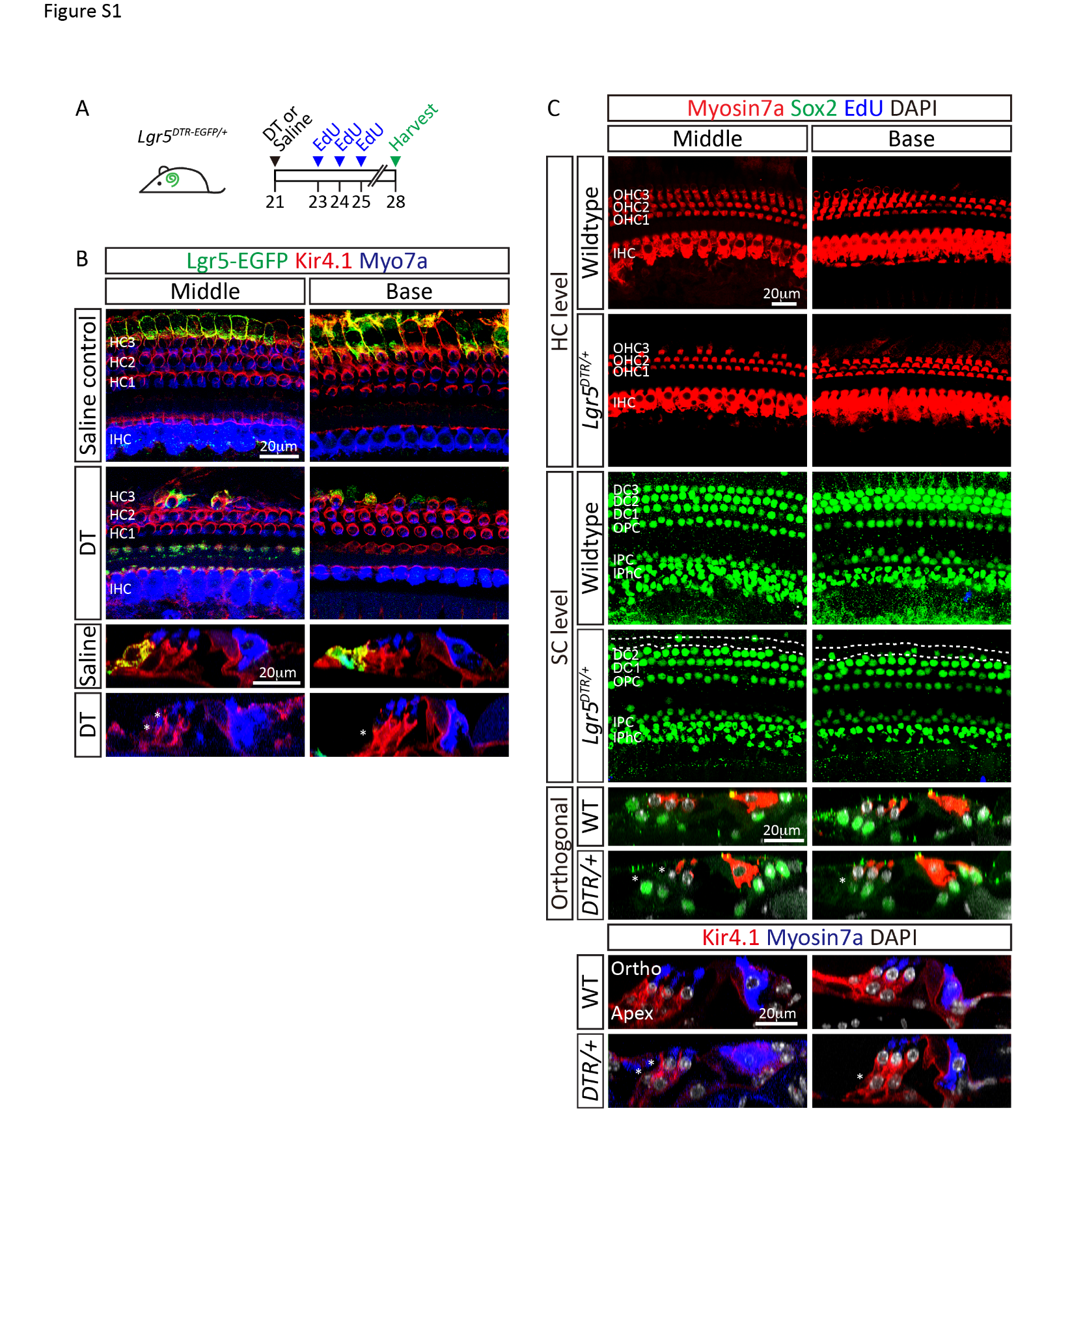

**Supplemental Figure 2**

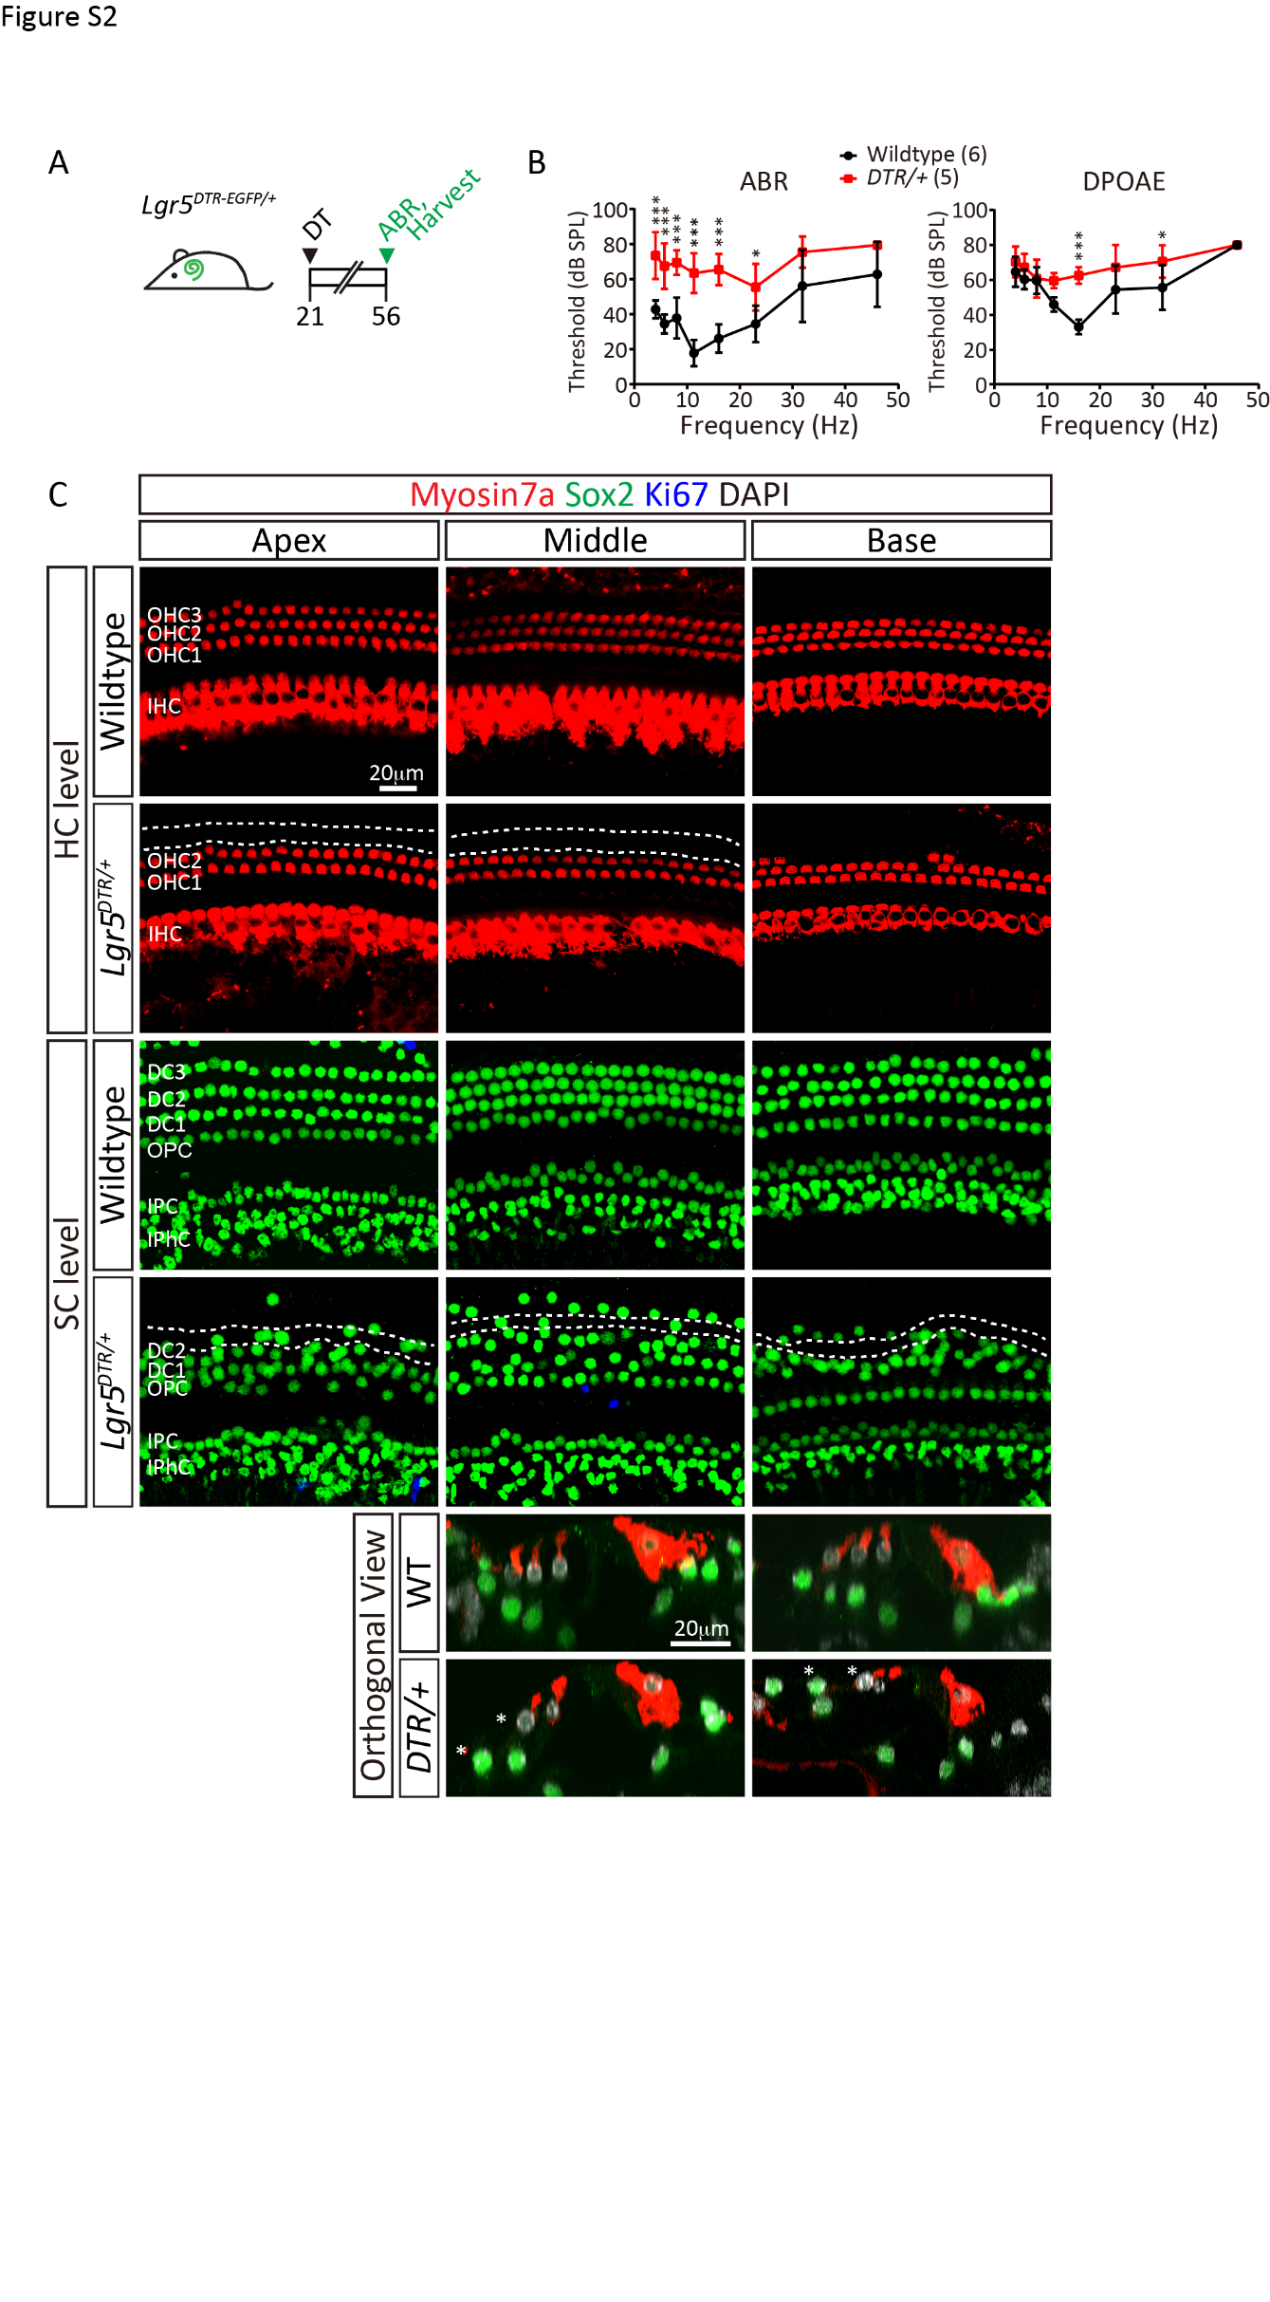

Supplemental Table 1. Quantification of hair cells and supporting cells in P28 cochlea

|  |  |  |  |  |  |
| --- | --- | --- | --- | --- | --- |
| Turn |  | IHC | OHC1 | OHC2 | OHC3 |
| Apex | Wildtype | 20.3±0.5 | 21.5±0.6 | 21.3±1.0 | 20.8±1.7 |
| Lgr5-DTR | 20.2±1.3 | 21.2±1.3 | 20.6±0.9 | 1.8±2.0*** |
| Middle | Wildtype | 21.0±1.6 | 21.0±0.8 | 21.3±1.0 | 21.0±1.4 |
| Lgr5-DTR | 21.8±0.8 | 20.6±0.5 | 21.0±0.7 | 4.6±3.5*** |
| Base | Wildtype | 20.0±0.0 | 19.5±0.6 | 18.0±1.4 | 20.3±0.5 |
| Lgr5-DTR | 19.4±0.9 | 19.0±0.7 | 18.4±0.5 | 15.4±1.9* |

|  |  |  |  |  |  |  |
| --- | --- | --- | --- | --- | --- | --- |
| Turn |  | IPhC | PC | DC1 | DC2 | DC3 |
| Apex | Wildtype | 47.0±2.9 | 51.0±0.8 | 21.3±0.5 | 20.5±0.6 | 21.3±1.5 |
| Lgr5-DTR | 45.8±1.8 | 51.0±0.7 | 21.2±1.3 | 19.2±1.1 | 1.2±1.3*** |
| Middle | Wildtype | 46.0±2.2 | 52.0±1.6 | 20.5±0.6 | 21.0±1.2 | 21.0±0.8 |
| Lgr5-DTR | 46.0±3.7 | 53.4±1.1 | 20.8±0.4 | 20.4±1.8 | 2.0±1.6*** |
| Base | Wildtype | 45.0±2.2 | 50.8±1.0 | 19.0±0.0 | 20.0±0.8 | 20.0±0.8 |
| Lgr5-DTR | 41.4±2.8 | 49.4±0.5 | 19.0±1.0 | 18.6±1.1 | 12.2±2.4*** |

-Shown are Myosin7a+ hair cell and Sox2+ supporting cell counts per 160 μm cochlear length from P28 mice. Mean±S.D. n=4-5.

*** denotes p<0.001 and * denotes p<0.05 between wildtype and Lgr5-DTR treated groups (two-way analysis of variance with Tukey’s multiple comparisons test).

-IHC=inner hair cells, OHC1=first row of outer hair cells, OHC2=second row of outer hair cells, OHC3=third row of outer hair cells, IPhC=inner phalangeal cells, PC=pillar cells, DC1=first row of Deiters’ cells, DC2=second row of Deiters’ cells, DC3=third row of Deiters’ cells.

Supplemental Table 2. Quantification of Kir4.1+ Deiters’ cells

|  |  |  |  |
| --- | --- | --- | --- |
| Turn |  | DC1 | DC2 |
| Apex | Saline | 21.4±1.4 | 21.1±0.7 |
| DT | 21.2±0.8 | 19.6±1.5 |
| Middle | Saline | 21.1±0.7 | 21.4±0.9 |
| DT | 21.6±2.8 | 21.2±1.5 |
| Base | Saline | 18.6±0.9 | 19.5±1.3 |
| DT | 19.6±0.8 | 21.2±0.8 |

-Shown are Kir4.1+ Deiters’ cell counts per 160 μm cochlear length from P28 mice. Mean±S.D. n=4-5.

-There were no significant differences (P>0.05) in number of DC1 or DC2 of apical, middle and basal turn between saline control and Lgr5-DTR treated groups (two-way analysis of variance with Tukey’s multiple comparisons test).

-DC1=first row of Deiters’ cell, DC2=second row of Deiters’ cell.

Supplemental Table 3. Quantification of Lgr5-EGFP+ Deiters’ cells

|  |  |  |  |
| --- | --- | --- | --- |
|  | Apex | Middle | Base |
| Saline | 22.1±1.3 | 21.1±0.7 | 18.9±0.7 |
| DT | 0.0±0.0*** | 5.6±3.1*** | 6.8±2.7*** |

-Shown are Lgr5-EGFP+ Kir4.1+ 3rd Deiters’ cell counts per 160 μm cochlear length from P28 mice. Mean±S.D. n=4-5.

*** denotes p<0.001 between saline control and Lgr5-DTR treated groups.

(two-way analysis of variance with Tukey’s multiple comparisons test).

Supplemental Table 4. Quantification of hair cells and supporting cells in P56 cochlea

|  |  |  |  |  |  |
| --- | --- | --- | --- | --- | --- |
| Turn |  | IHC | OHC1 | OHC2 | OHC3 |
| Apex | Wildtype | 19.7±0.8 | 20.8±0.8 | 20.7±0.8 | 21.2±0.8 |
| Lgr5-DTR | 20.0±0.7 | 20.4±0.9 | 20.0±0.7 | 0.8±1.8*** |
| Middle | Wildtype | 21.2±0.4 | 22.0±0.9 | 20.8±1.2 | 21.0±1.3 |
| Lgr5-DTR | 21.6±1.8 | 20.4±0.5 | 20.4±1.1 | 0.2±0.4*** |
| Base | Wildtype | 19.8±1.2 | 19.2±0.8 | 17.5±1.0 | 17.2±1.7 |
| Lgr5-DTR | 19.4±1.1 | 19.6±1.8 | 16.8±2.4 | 3.8±2.9*** |

|  |  |  |  |  |  |  |
| --- | --- | --- | --- | --- | --- | --- |
| Turn |  | IPhC | PC | DC1 | DC2 | DC3 |
| Apex | Wildtype | 45.3±2.3 | 52.0±0.9 | 21.2±0.8 | 21.2±0.4 | 21.3±0.5 |
| Lgr5-DTR | 44.0±1.2 | 50.4±0.9 | 21.2±0.8 | 17.0±2.3** | 1.0±1.0*** |
| Middle | Wildtype | 45.2±3.1 | 54.0±1.5 | 21.7±0.5 | 21.7±1.4 | 20.8±0.8 |
| Lgr5-DTR | 46.6±4.3 | 52.6±1.1 | 20.0±1.0 | 18.4±1.8* | 0.2±0.4*** |
| Base | Wildtype | 45.3±3.1 | 49.3±1.0 | 19.0±0.9 | 18.8±0.8 | 19.0±1.2 |
| Lgr5-DTR | 43.4±3.5 | 51.0±1.0 | 19.6±2.1 | 18.6±2.1 | 3.4±4.5*** |

-Shown are Myosin7a+ hair cell and Sox2+ supporting cell counts per 160 μm cochlear length from P56 mice. Mean±S.D. n=4-5.

*** p<0.001, ** p<0.01 and * p<0.05 between wildtype and Lgr5-DTR treated groups. (two-way analysis of variance with Tukey’s multiple comparisons test).

IHC=inner hair cells, OHC1=first row of outer hair cells, OHC2=second row of outer hair cells, OHC3=third row of outer hair cells, DC=Deiters’ cells, IPhC=inner phalangeal cells, PC=pillar cells, DC1=first row of Deiters’ cells, DC2=second row of Deiters’ cells, DC3=third row of Deiters’ cells.